

500th major PAS-X MES facility go-live:
CELLforCURE by SEQENS trusts on Körber for lean and compliant processes

Lüneburg, Germany, 21 May 2025. CELLforCURE by SEQENS implements Körber’s PAS-X MES 3.3 as a Software as a Service (SaaS) solution hosted on the AWS cloud at its site in Les Ulis, France. For Körber, this project marks the 500th major PAS-X MES facility go-live – a great success that representatives from Körber and CELLforCURE by SEQENS celebrated at the Software Pharma Open event in Hamburg, Germany.

CELLforCURE by SEQENS, a leading contract development and manufacturing organization (CDMO) for cell and gene therapies, has chosen to implement Körber’s PAS-X MES 3.3 as a crucial component of its digitalization strategy for manufacturing, traceability and documentation processes.

As a specialized CDMO, CELLforCURE by SEQENS needed a digital solution to ensure seamless technology transfer and process validation for its clients, supporting clinical & commercial supply, as well as an efficient batch information exchange system with its customers. Given the highly personalized nature of cell and gene therapies, characterized by small batch sizes and time pressure, it was also essential to reduce the effort required for handling and documentation, lower operational costs, and secure reliable IT support.

“We chose PAS-X MES because we believe it offers the best functional coverage in a SaaS environment compared to other solutions. By leveraging an MES as a service, we no longer need to manage IT infrastructure internally. This solution permits to ensure lean and compliant processes for patients’ batches manufacturing and release. We will be able to exchange data with our customers very effectively”, says Nathalie Lelot, Operations Head at CELLforCURE by SEQENS.

PAS-X MES is being deployed as a standard out-of-the-box SaaS solution, hosted in an AWS cloud environment and fully managed by Körber. It covers Master Batch Record (MBR) design, execution, and documentation. The system integrates with scales and printers and is connected to the SAP ERP system via SAP MII. Körber’s PAS-X Data Access will also be utilized to provide curated data for Power BI analysis, enabling the establishment of KPIs and further process optimization.

Picture
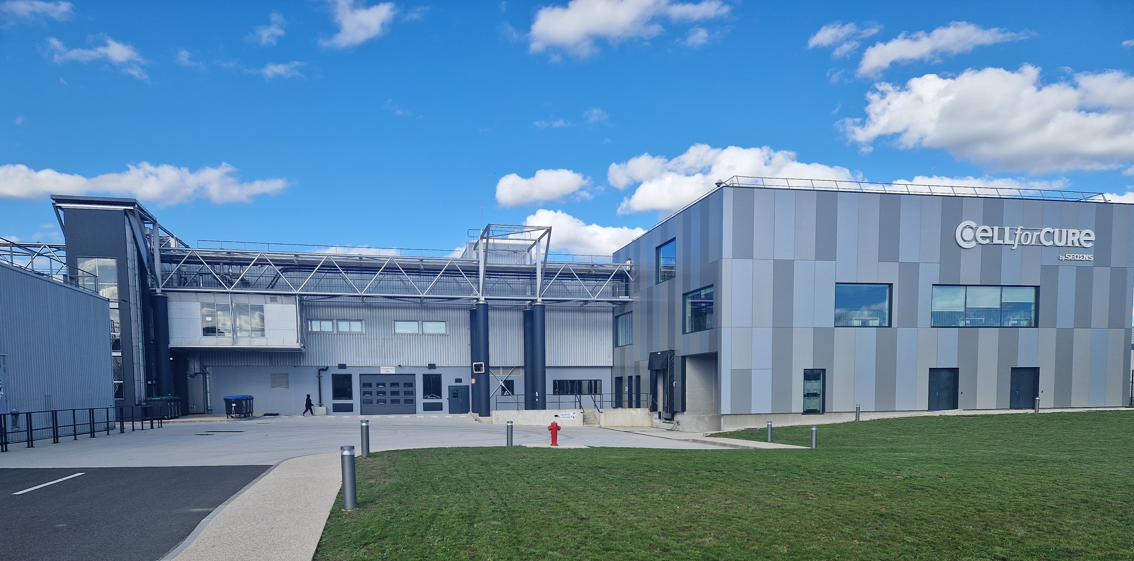
CELLforCURE by SEQENS site in Les Ulis, France

Picture from award ceremony at Software Pharma Open
Sebastian Bien, VP Sales EMEA Software, Körber BA Pharma, and Nathalie Lelot, Operations Head, CELLforCURE by SEQENS, celebrate the 500th major PAS-X MES facility go-live

About CELLforCURE by SEQENS
Operated by CELLforCURE SAS, CELLforCURE by SEQENS is a CDMO authorized by French Health Authorities, dedicated to ATMP production from concept to commercialization. With advanced technologies, extensive capabilities, and large-scale capacity, CELLforCURE by SEQENS offers a seamless journey from early-stage development to commercial manufacturing of a wide range of cell therapies. CELLforCURE by SEQENS is part of the SEQENS Group, a global partner in health, personal care and specialty ingredients, leveraging 3300 employees, 16 manufacturing sites and 9 R&D centers in 9 countries.
cellandgene.seqens.com

Contact
press@seqens.com

About Körber
We are Körber – an international technology group with around 13,000 employees at over 100 locations worldwide and a common goal: We turn entrepreneurial thinking into customer success and shape the technological change. In the Business Areas Digital, Pharma, Supply Chain, and Technologies, we offer products, solutions and services that inspire. We act fast to customer needs, we execute ideas seamlessly, and with our innovations we create added value for our customers. In doing so, we are increasingly building on ecosystems that solve the challenges of today and tomorrow. Körber AG is the holding company of the Körber Group.

At Körber Business Area Pharma, we deliver the difference by empowering our customers with a holistic ecosystem approach. Our unique portfolio of end-to-end solutions ranges from machines – for aseptic processing, inspection, packaging and materials, and transport systems – to consulting, services, software, and digital and AI-driven solutions that serve as integrating layers to boost pharmaceutical manufacturing.

We simplify processes, reduce risks and accelerate time-to-market – ensuring smooth collaboration along the entire pharmaceutical and biotech value chain. With deep industry expertise, we support global customers unlock new potential. Our solutions support a better quality of life for both present and future generations.

www.koerber-pharma.com

Contact
Dirk Ebbecke
Körber Business Area Pharma
Head of Product Marketing
T: +49 4131 8900-0
E-mail: dirk.ebbecke@koerber.com

