Körber wins renowned Pro Carton ECMA Gold Award with Pharma packaging solutions

Allschwil, October 26, 2020 - The Körber Business Area Pharma has already made it to the finalists of the European Carton Excellence Award several times with various packaging solutions. Now the flexible cardboard packaging for a wide range of clinical vials competence area "Packaging Materials" has received the prestigious Gold Award.

At a time when a particularly large number of drugs are being tested in studies, such as the current COVID 19 pandemic, the number of different primary packaging is increasing. This is because the large number of different ampoule and vial sizes requires new packaging designs time and again. "For many manufacturers, this is a rather tiresome and cost-intensive issue. What's more, the different types of packaging take up a lot of storage space," says Joachim Hoeltz, Chief Executive Officer Packaging Materials in the Körber Business Area Pharma. "Our long-standing customer UCB therefore approached us with the idea of finding a sustainable solution to this issue together.

One packaging solution for different medicines

Product developer Cecile Zimmermann and the innovation team for packaging materials from the Business Area Pharma developed a secondary packaging consisting of two units: an inner and an outer box. Thanks to flexible tabs in the inner box, different product sizes can be securely packed in just one packaging solution. The products are optimally fixed and protected regardless of their size. Pharmaceutical manufacturers can thus reduce the large number of secondary packages to a minimum.

"Together with UCB, we have found a solution that is unique and takes a real load off our customers' shoulders," says Hoeltz. "They can now concentrate fully on developing and testing new products."

Winning the European Carton Excellence Award is already the second major award this year in this area for Körber: At the beginning of the year, the team also won the Pharmapack Award for its Smart Package. The intelligent drug packaging serves as a communication medium with the patient and offers him or her a gateway to valuable information and services in the digital world.

Further information on the sustainable packaging solutions of Körber's Business Area Pharma is available to interested parties at: https://www.koerber-pharma.com/en/solutions/packaging-materials

-End-

Photo


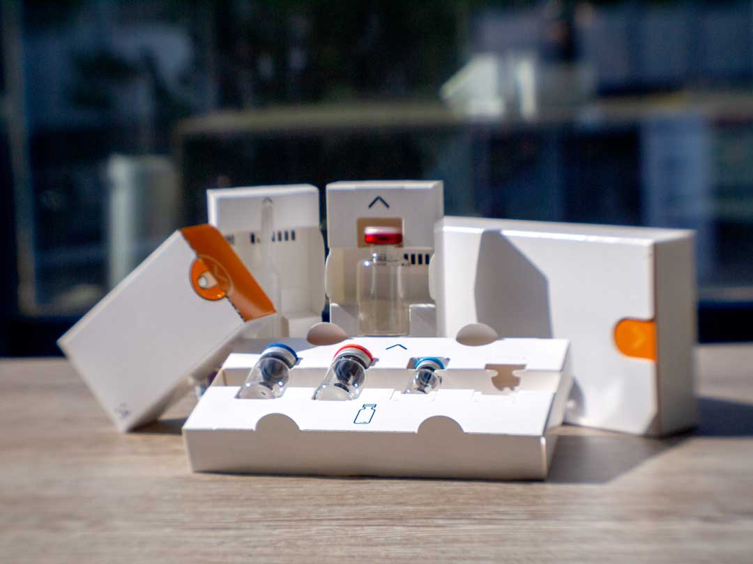

About Körber’s Business Area Pharma
At Körber Pharma, we deliver the difference along the entire pharmaceutical value chain by offering a unique portfolio of integrated solutions. Based on in-depth experience spanning consulting, inspection, transport systems, packaging machines and materials, track and trace and software, we understand the challenges in pharmaceutical processes and regulation that our customers face day to day, from the beginning to the end of their production. For them, we deliver the difference to unlock the potential of global pharmaceutical and biotech manufacturing: www.koerber-pharma.com

About Körber
We are Körber - an international technology group with about 10,000 employees, more than 100 locations worldwide and a common goal: We turn entrepreneurial thinking into customer success and shape technological change. In our five Business Areas Digital, Pharma, Supply Chain, Tissue and Tobacco, we offer products, solutions and services that inspire. We respond quickly to customer needs, we implement ideas seamlessly, and our innovations create added value for our customers. We are increasingly building on ecosystems that solve the challenges of today and tomorrow. Körber AG is the holding company of the Körber Group: www.koerber.com

Contact:

Morris Mentzel
Körber Business Area Pharma
Marketing Manager Packaging Materials
Gewerbestrasse 11, 4123 Allschwil, Switzerland
T +41 61 486 87 87
m.mentzel@rondo-packaging.com
rondo-packaging.com

